# Report 4: System Design Description (SDD)

## 4.1. Design Overview

* This document describes the technical and IU design of the OMCS system. It includes the architectural design and the detailed design of common functions and business functions. It also includes the design of database model.
* The architectural design describes the overall architecture of the system, and the architecture of each main component and subsystem. It will describe the patterns being used, the role of each component and the role of the system in the working environment.
* The detailed design describes static and dynamic structure for each component and function. It includes class diagrams, class explanations, and sequence diagrams of each use cases.
* The database design describes the relationship between entities, and details of each entity.

## 4.2. System Architectural Design

### 4.2.1. Choice of system architecture

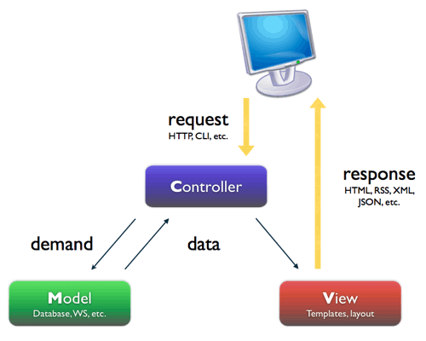

Figure 1: MVC Architecture

**(http://smist08.wordpress.com/tag/mvc/)**

* **The Model** is the part of the application that handles the logic for the application data.  
  Often model objects retrieve data (and store data) from a database.
* **The View** is the parts of the application that handles the display of the data.  
  Most often the views are created from the model data.
* **The Controller** is the part of the application that handles user interaction.  
  Typically controllers read data from a view, control user input, and send input data to the model.

**(**[**http://www.w3schools.com/aspnet/mvc_intro.asp**](http://www.w3schools.com/aspnet/mvc_intro.asp)**)**

### 4.2.2. Discussion of Alternative Designs

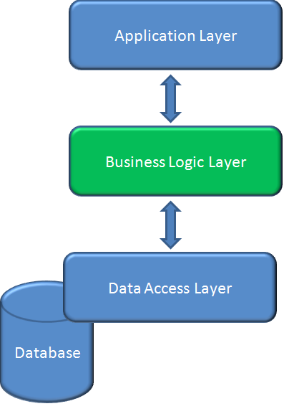

**Figure 2**: Three-layer architecture

* **Data layer:** is basically the server which stores all the application’s data.
* **Business layer:** is mainly working as the bridge between Data layer and Presentation layer. All the data passes through the Business layer before passing to the presentation layer. Business layer is the sum of Business Logic and other components used to add business logic.
* **Presentation layer:** is the layer in which the users interact with an application. Presentation layer contents Share UI code, Code Behind and Designers used to represent information to users.

### 4.2.3. Description of System Interface

### 4.2.3.1. User interfaces

* Because this is a website for medical consulting, so the user interface is simple and friendly.

### 4.2.3.2. Hardware interfaces

* The OMCS is intended as a website runs well on all web browsers. The website should be deployed online and accessible on any computer using different Operation Systems. At present, OMCS does not have mobile version.

### 4.2.3.3. Software interfaces

* The system should be able to run on any browser supported HTML 5.
* Any service exposed by the system should be accessible using HTTP protocol.

### 4.2.3.4. Communication interfaces

* The system uses HTTP protocol to communicate between server and clients.

## 4.3. Component Diagram

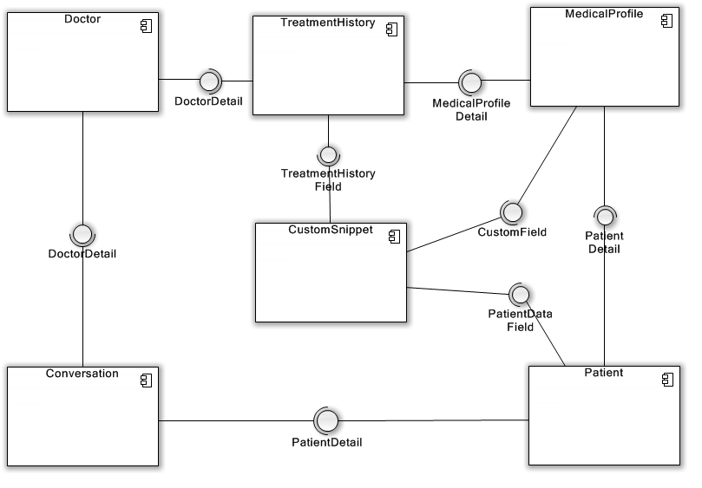

**Figure 3:** Component Diagram

## 4.4. Detailed Description of Components

### 4.4.1. Class Diagram

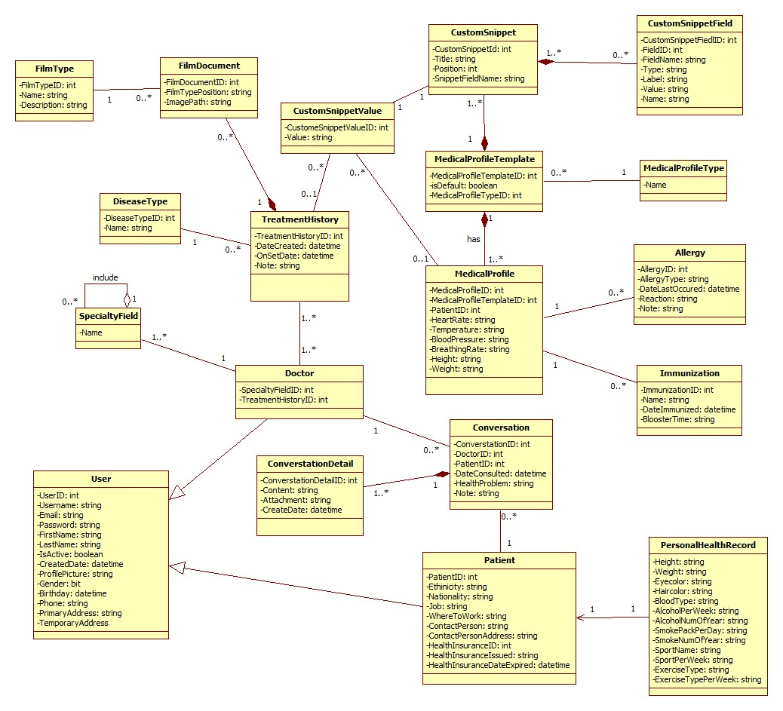

**Figure 4:** Class Diagram

### 4.4.2. Class Diagram Explanation

### 4.4.2.1. User Model

|  |  |  |  |
| --- | --- | --- | --- |
| **Attribute Name** | **Type** | **Visibility** | **Description** |
| UserID | int | public | ID of the user |
| Username | string | public | User name of the user |
| Email | string | public | Email of the user |
| Password | string | public | Password of the user |
| FirstName | string | public | First name of the user |
| LastName | string | public | Last name of the user |
| IsActive | boolean | public | Condition of the user’s account |
| CreatedDate | datetime | public | Created date of the user’s account |
| ProfilePicture | string | public | Profile picture name of the user |
| Gender | string | public | Gender of the user |
| Birthday | datetime | public | Birthday of the user |
| Phone | string | public | Phone of the user |
| PrimaryAddress | string | public | Primary address of the user |
| SecondaryAddress | string | public | Secondary address of the user |

### 4.4.2.2. SpecialtyField Model

|  |  |  |  |
| --- | --- | --- | --- |
| **Attribute Name** | **Type** | **Visibility** | **Description** |
| Name | string | public | Name of the specialty field |

### 4.4.2.3. DiseaseType Model

|  |  |  |  |
| --- | --- | --- | --- |
| **Attribute Name** | **Type** | **Visibility** | **Description** |
| DiseaseTypeID | int | public | ID of the disease type |
| Name | string | public | Name of the disease type |

### 4.4.2.4. FilmType Model

|  |  |  |  |
| --- | --- | --- | --- |
| **Field Name** | **Type** | **Visibility** | **Description** |
| FilmTypeID | int | public | ID of the film type |
| Name | string | public | Name of the film type |
| Description | string | public | Description of the film type |

### 4.4.2.5. FilmDocument Model

|  |  |  |  |
| --- | --- | --- | --- |
| **Field Name** | **Type** | **Visibility** | **Description** |
| FilmDocumentID | int | public | ID of the film document |
| FilmTypePosition | string | public | Position of the film type |
| ImagePath | string | public | Path of the image |

### 4.4.2.6. CustomSnippetValue Model

|  |  |  |  |
| --- | --- | --- | --- |
| **Field Name** | **Type** | **Visibility** | **Description** |
| CustomSnippetValueID | int | public | ID of the custom snippet value |
| Value | string | public | Value of the custom snippet |

### 4.4.2.7. TreatmentHistory Model

|  |  |  |  |
| --- | --- | --- | --- |
| **Field Name** | **Type** | **Visibility** | **Description** |
| TreatmentHistoryID | int | public | ID of the treatment history |
| DateCreated | datetime | public | Created date of the treatment history |
| OnSetDate | datetime | public | Set date of the treatment history |
| Note | string | public | Note of the treatment history |

### 4.4.2.8. Doctor Model

|  |  |  |  |
| --- | --- | --- | --- |
| **Field Name** | **Type** | **Visibility** | **Description** |
| SpecialtyFieldID | int | public | ID of the specialty field |
| TreatmentHistoryID | int | public | ID of the treatment history |

### 4.4.2.9. ConversationDetail Model

### 4.4.2.10. CustomSnippet Model

|  |  |  |  |
| --- | --- | --- | --- |
| **Field Name** | **Type** | **Visibility** | **Description** |
| CustomSnippetID | int | public | ID of the custom snippet |
| Title | string | public | Title of the custom snippet |
| Position | int | public | Position of the custom snippet |
| SnippetFieldName | string | public | Name of the snippet field |

### 4.4.2.11. MedicalProfileTemplate Model

### 4.4.2.12. MedicalProfile Model

### 4.4.2.13. Conversation Model

|  |  |  |  |
| --- | --- | --- | --- |
| **Field Name** | **Type** | **Visibility** | **Description** |
| ConversationID | int | public | ID of the conversation |
| PatientID | int | public | ID of the patient |
| DoctorID | int | public | ID of the doctor |
| DateConsulted | datetime | public | Consulted date of the conversation |
| HealthProblem | string | public | Health problem of the conversation |
| Note | string | public | Note of the conversation |

### 4.4.2.14. Patient Model

### 4.4.2.15. CustomSnippetField Model

### 4.4.2.16. MedialProfileType Model

|  |  |  |  |
| --- | --- | --- | --- |
| **Field Name** | **Type** | **Visibility** | **Description** |
| Name | string | public | Name of the medical profile type |

### 4.4.2.17. Allergy Model

|  |  |  |  |
| --- | --- | --- | --- |
| **Field Name** | **Type** | **Visibility** | **Description** |
| AllergyID | int | public | ID of the allergy |
| AllergyTypeID | int | public | ID of the allergy type |
| DateLastOccurred | datetime | public | Last occurred date of the allergy |
| Reaction | string | public | Reaction of the allergy |
| Note | string | public | Note of the allergy |

### 4.4.2.18. Immunization Model

|  |  |  |  |
| --- | --- | --- | --- |
| **Field Name** | **Type** | **Visibility** | **Description** |
| ImmunizationId | int | public | ID of the immunization |
| Name | string | public | Name of the immunization |
| DateImmunized | datetime | public | Immunized date |
| BoosterTime | int | public | Booster time |

### 4.4.2.19. PersonalHealthRecord Model

## 4.5. Sequence Diagram

### 4.5.1. Common

### 4.5.1.1. Login

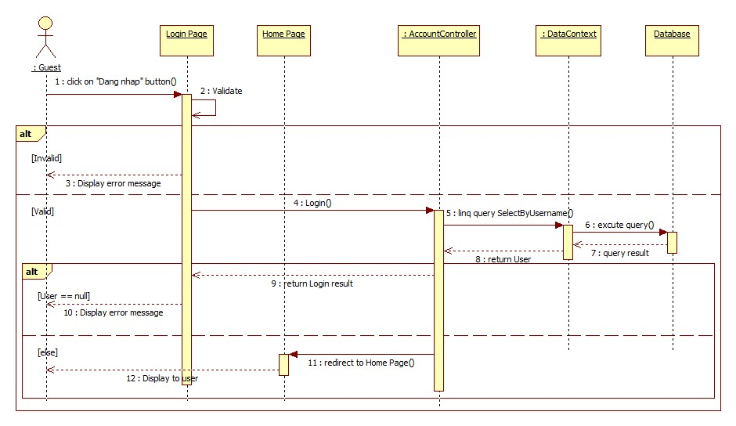

**Figure 5:** Login

### 4.5.1.2. Register

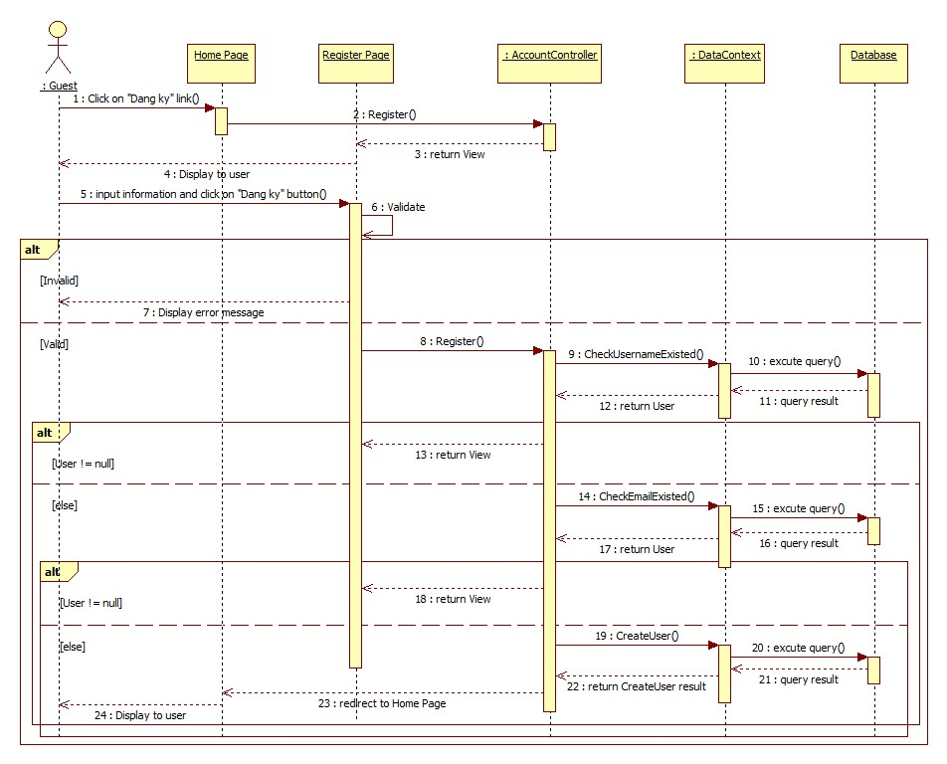

**Figure 6:** Register

### 4.5.2. Update Account Profile

### 4.5.2.1. Change Password

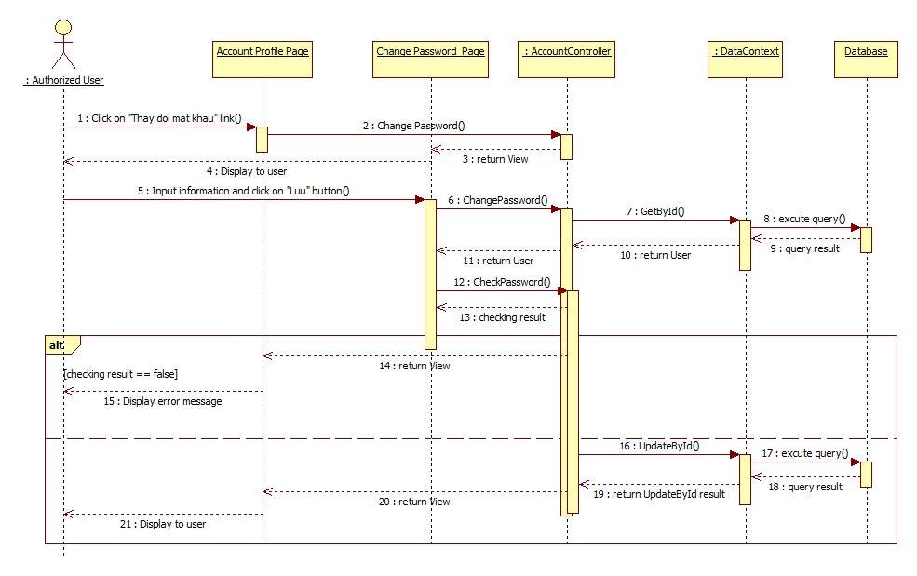

**Figure 7:** Change Password

### 4.5.2.2. Change Profile Picture

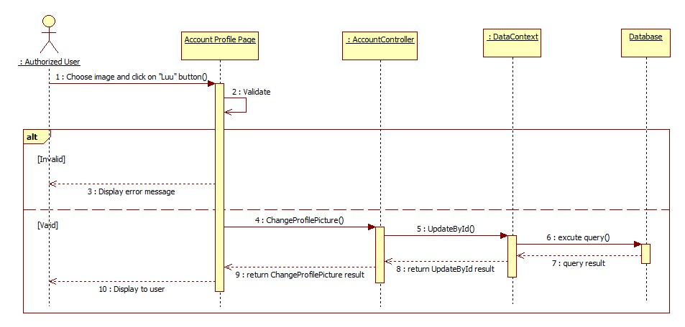

**Figure 8:** Change Profile Picture

### 4.5.3. Consult Online

### 4.5.3.1. Conversation

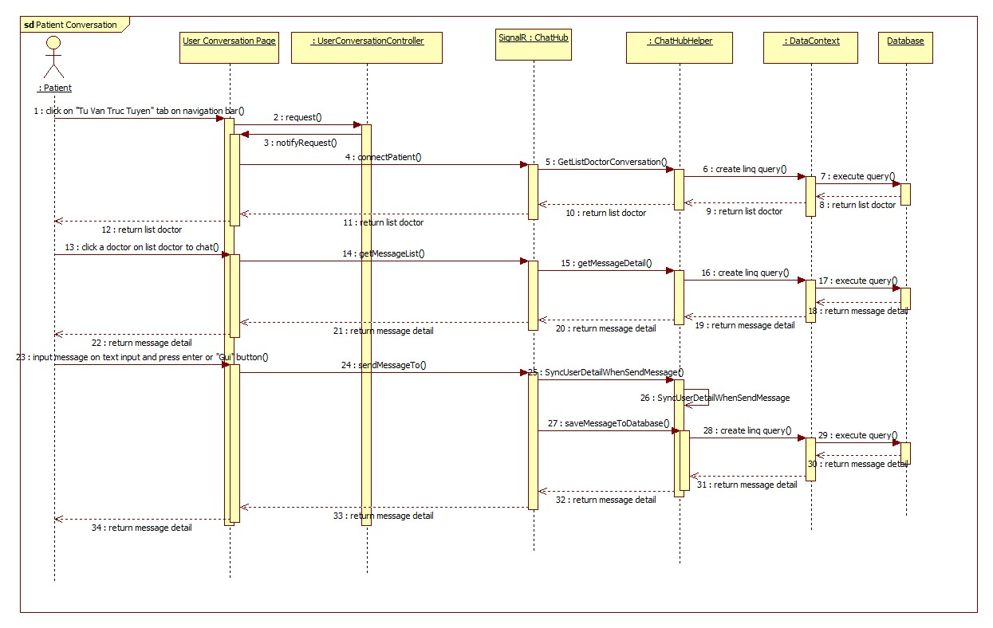

**Figure 9:** Patient Conversation

### 4.5.3.2. Request Webcam

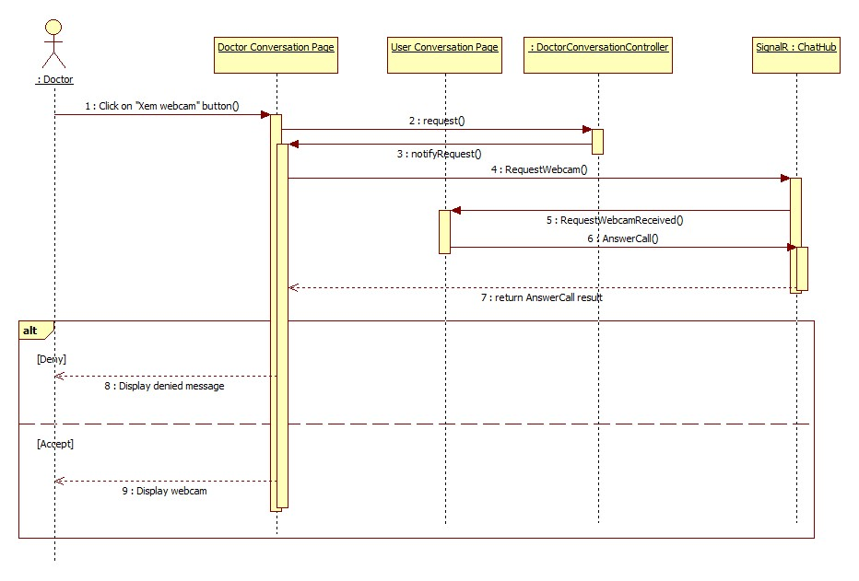

**Figure 10:** Request Webcam

### 4.5.3.3. Show Webcam

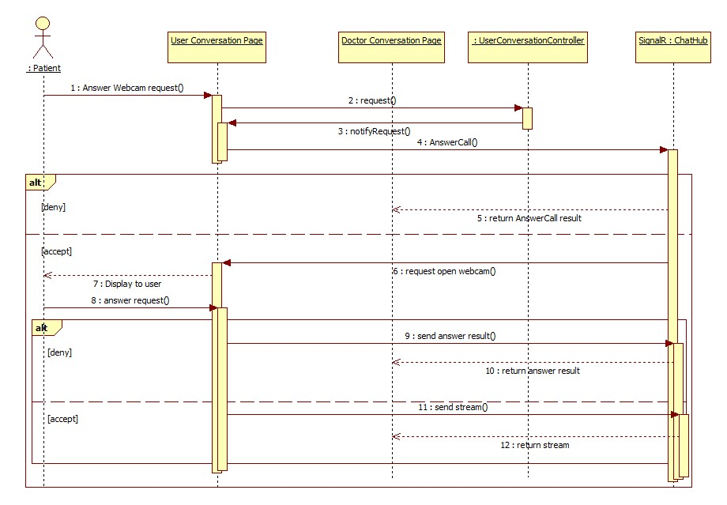

**Figure 11:** Show Webcam

### 4.5.3.4. Upload Attachment

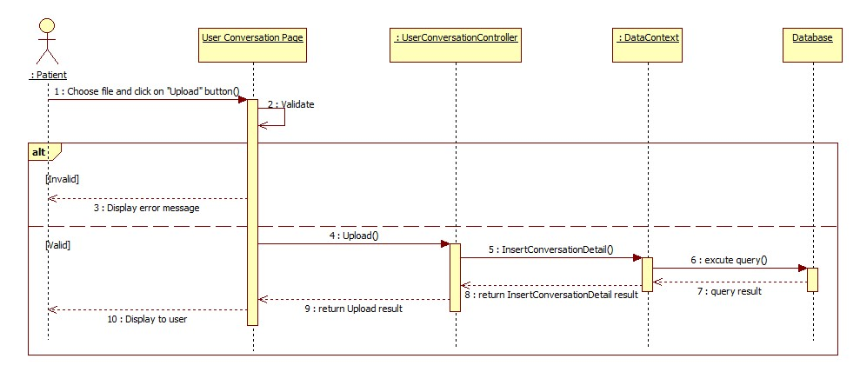

**Figure 12:** Upload Attachment

### 4.5.4. Define New Medical Profile Template

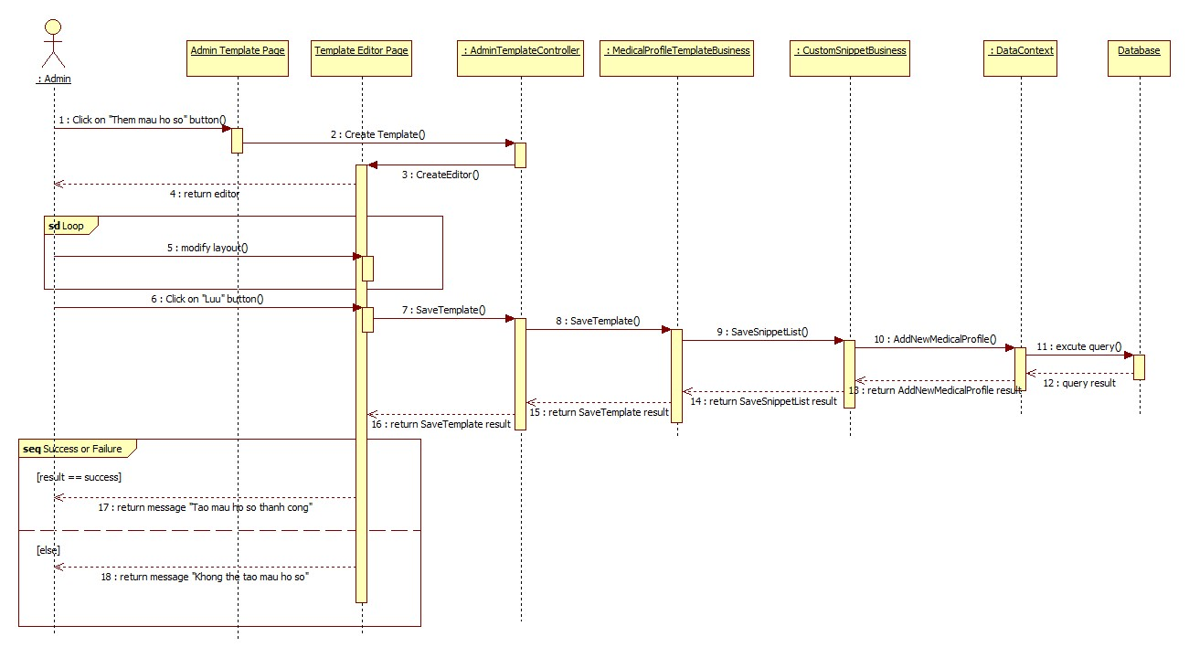

**Figure 13:** Define New Medical Profile Template

### 4.5.5. View Medical Profile Record

### 4.5.5.1. (Patient) View Medical Profile Record

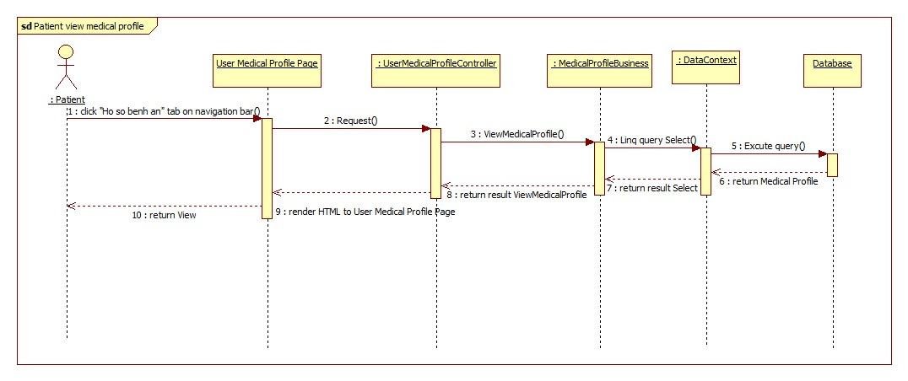

**Figure 14:** (Patient) Views Medical Profile

### 4.5.5.2. Doctor Views Medical Profile Record

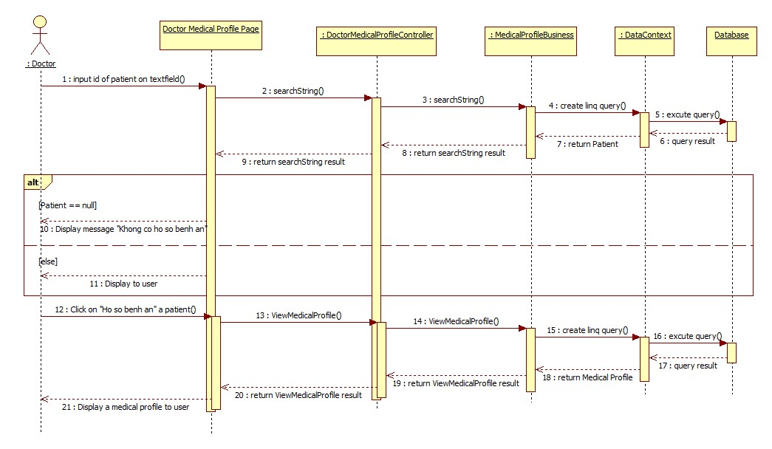

**Figure 15:** (Doctor) View Medical Profile

### 4.5.6. Update Medical Profile

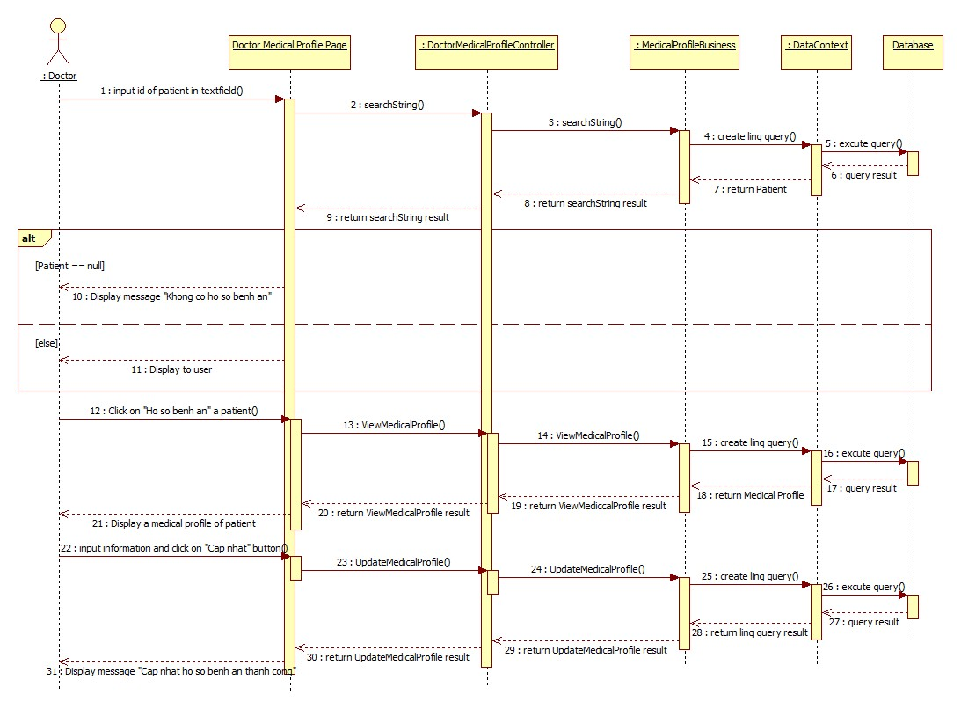

**Figure 16:** Update Medical Profile

### 4.5.7. Update Personal Health Record

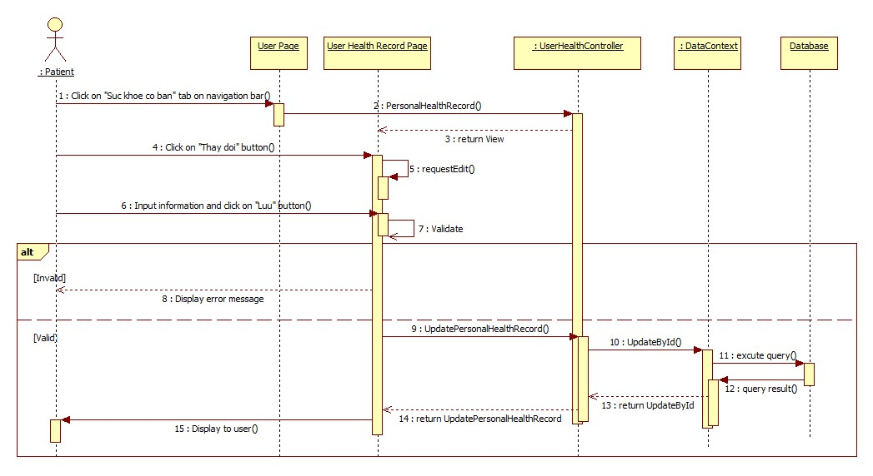

**Figure 17:** Update Personal Health Record

## 4.6. Database Design

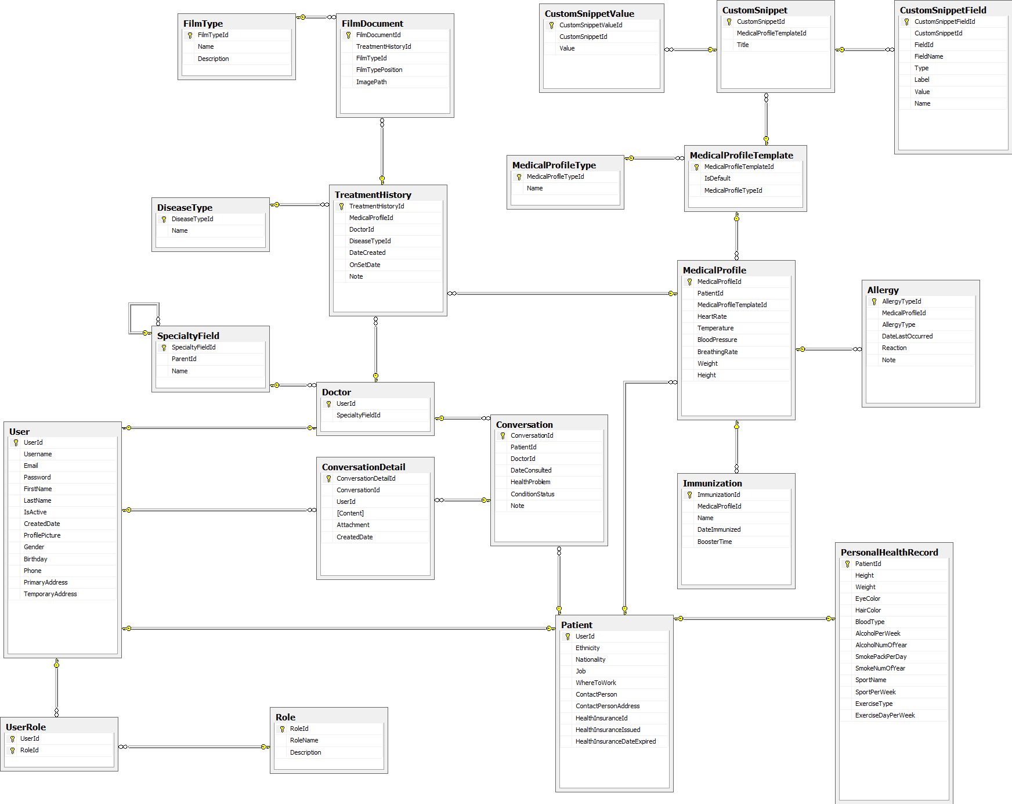

**Figure 18:** Database Physical Diagram

### 4.6.1. User Table

|  |  |  |  |  |
| --- | --- | --- | --- | --- |
| **Field Name** | **Type** | **Null** | **P/F Key** | **Description** |
| UserId | int |  | PK | ID of the user |
| Username | nvarchar(50) |  |  | User name of the user |
| Email | nvarchar(50) |  |  | Email of the user |
| Password | nvarchar(50) |  |  | Password of the user |
| FirstName | nvarchar(50) | ✓ |  | First name of the user |
| LastName | nvarchar(50) | ✓ |  | Last name of the user |
| IsActive | Bit |  |  | Condition of the user’s account |
| CreatedDate | datetime |  |  | Created date of the user’s account |
| ProfilePicture | nvarchar(MAX) | ✓ |  | Profile picture name of the user |
| Gender | nvarchar(MAX) | ✓ |  | Gender of the user |
| Birthday | datetime | ✓ |  | Birthday of the user |
| Phone | nvarchar(MAX) | ✓ |  | Phone of the user |
| PrimaryAddress | nvarchar(MAX) | ✓ |  | Primary address of the user |
| SecondaryAddress | nvarchar(MAX) | ✓ |  | Secondary address of the user |

### 4.6.2. UserRole Table

|  |  |  |  |  |
| --- | --- | --- | --- | --- |
| **Field Name** | **Type** | **Null** | **P/F Key** | **Description** |
| UserId | int |  | PK | ID of the user |
| RoleId | int |  | FK | ID of the role |

### 4.6.3. Role Table

|  |  |  |  |  |
| --- | --- | --- | --- | --- |
| **Field Name** | **Type** | **Null** | **P/F Key** | **Description** |
| RoleId | int |  | PK | ID of the role |
| RoleName | nvarchar(MAX) |  |  | Name of the role |
| Description | nvarchar(MAX) |  |  | Description of the role |

### 4.6.4. SpecialtyField Table

|  |  |  |  |  |
| --- | --- | --- | --- | --- |
| **Field Name** | **Type** | **Null** | **P/F Key** | **Description** |
| SpecialtyFieldId | int |  | PK | ID of the specialty field |
| ParentId | int |  | FK | ID of the parent specialty field |
| Name | nvarchar(MAX) |  |  | Description of the role |

### 4.6.5. PersonalHealthRecord Table

|  |  |  |  |  |
| --- | --- | --- | --- | --- |
| **Field Name** | **Type** | **Null** | **P/F Key** | **Description** |
| PatientId | int |  | PK | ID of the patient |
| Height | float |  |  | Height of the patient |
| Weight | float |  |  | Weight of the patient |
| EyeColor | nvarchar(MAX) | ✓ |  | Eye color of the patient |
| HairColor | nvarchar(MAX) | ✓ |  | Hair color of the patient |
| BloodType | nvarchar(MAX) | ✓ |  | Blood type of the patient |
| AlcoholPerWeek | float |  |  | Drinking alcohol per week of the patient |
| AlcoholNumOfYear | int |  |  | Number of year that drink alcohol |
| IsBeer | bit |  |  | Is patient drinking beer? |
| SmokePackPerWeek | float |  |  | Smoke pack using per week |
| SmokeNumOfYear | int |  |  | Number of year that smoke |
| SportName | nvarchar(MAX) | ✓ |  | Sport name that patient plays |
| SportPerWeek | int |  |  | Times that patient plays sport |
| ExerciseType | nvarchar(MAX) | ✓ |  | Type of the exercise |
| ExercisePerWeek | int |  |  | Times of exercising per week |

### 4.6.6. Patient Table

|  |  |  |  |  |
| --- | --- | --- | --- | --- |
| **Field Name** | **Type** | **Null** | **P/F Key** | **Description** |
| UserId | int |  | PK, FK | ID of the user |
| Ethnicity | nvarchar(MAX) | ✓ |  | Ethnicity of the patient |
| Nationality | nvarchar(MAX) | ✓ |  | Nationality of the patient |
| Job | nvarchar(MAX) | ✓ |  | Job of the patient |
| WhereToWork | nvarchar(MAX) | ✓ |  | Workplace of the patient |
| ContactPerson | nvarchar(MAX) | ✓ |  | Contact person of the patient |
| ContactPersonAddress | nvarchar(MAX) | ✓ |  | Contact person address of the patient |
| HealthInsuranceId | nvarchar(MAX) | ✓ |  | ID of health insurance |
| HealthInsuranceIssued | datetime | ✓ |  | Health insurance issued |
| HealthInsuranceDateExpired | datetime | ✓ |  | Expiring date of health insurance |

### 4.6.7. MedicalProfileType Table

|  |  |  |  |  |
| --- | --- | --- | --- | --- |
| **Field Name** | **Type** | **Null** | **P/F Key** | **Description** |
| MedicalProfileTypeId | int |  | PK | ID of the medical profile type |
| Name | nvarchar(MAX) | ✓ |  | Name of the medical profile type |

### 4.6.8. MedicalProfileTemplate Table

|  |  |  |  |  |
| --- | --- | --- | --- | --- |
| **Field Name** | **Type** | **Null** | **P/F Key** | **Description** |
| MedicalProfileId | int |  | PK | ID of the medical profile |
| PatientId | bit |  | FK | ID of the patient |
| MedicalProfileKey | nvarchar(MAX) | ✓ |  | Medical profile key |
| CreatedDate | int |  |  | Created date of medical profile |
| MedicalProfileTemplateId | int |  |  | ID of the medical profile template |

### 4.6.9. Immunization Table

|  |  |  |  |  |
| --- | --- | --- | --- | --- |
| **Field Name** | **Type** | **Null** | **P/F Key** | **Description** |
| ImmunizationId | int |  | PK | ID of the immunization |
| MedicalProfileId | int |  | FK | ID of the immunization |
| Name | nvarchar(MAX) | ✓ |  | Name of the immunization |
| DateImmunized | datetime |  |  | Immunized date |
| BoosterTime | int |  |  | Booster time |

### 4.6.10. FilmType Table

|  |  |  |  |  |
| --- | --- | --- | --- | --- |
| **Field Name** | **Type** | **Null** | **P/F Key** | **Description** |
| FilmTypeId | int |  | PK | ID of the film type |
| Name | nvarchar(MAX) | ✓ |  | Name of the film type |
| Description | nvarchar(MAX) | ✓ |  | Description of the film type |

### 4.6.11. FilmDocument Table

|  |  |  |  |  |
| --- | --- | --- | --- | --- |
| **Field Name** | **Type** | **Null** | **P/F Key** | **Description** |
| FilmDocumentId | int |  | PK | ID of the film document |
| TreatmentHistoryId | int | ✓ | FK | ID of the treatment history |
| MedicalProfileId | int | ✓ | FK | ID of the medical profile |
| DoctorId | int |  | FK | ID of the doctor |
| FilmTypeId | int |  | FK | ID of the film type |
| DateCreated | datetime |  |  | Created date of the film document |
| Description | nvarchar(MAX) | ✓ |  | Description of the film document |
| Conclusion | nvarchar(MAX) | ✓ |  | Conclusion of the film document |
| FilmTypePosition | int |  |  | Position of the film type |
| ImagePath | nvarchar(MAX) | ✓ |  | Path of the image |

### 4.6.12. Doctor Table

|  |  |  |  |  |
| --- | --- | --- | --- | --- |
| **Field Name** | **Type** | **Null** | **P/F Key** | **Description** |
| UserId | int |  | PK | ID of the user |
| SpecialtyFieldId | int |  | FK | ID of the specialty |
| IsOnline | bit |  |  | Online condition of the user |
| Rating | float |  |  | Rating that the doctor is rated |
| Votes | int |  |  | Number of rating |

### 4.6.13. CustomSnippetValue Table

|  |  |  |  |  |
| --- | --- | --- | --- | --- |
| **Field Name** | **Type** | **Null** | **P/F Key** | **Description** |
| CustomSnippetValueId | int |  | PK | ID of the custom snippet value |
| CustomSnippetId | int |  | FK | ID of the custom snippet |
| MedicalProfileId | int |  | FK | ID of the medical profile |
| TreatmentHistoryId | int |  | FK | ID of the treatment history |
| Value | nvarchar(MAX) |  |  | Value of the custom snippet |

### 4.6.14. TreatmentHistory Table

|  |  |  |  |  |
| --- | --- | --- | --- | --- |
| **Field Name** | **Type** | **Null** | **P/F Key** | **Description** |
| TreatmentHistoryId | int |  | PK | ID of the treatment history |
| MedicalProfileId | int |  | FK | ID of the medical profile |
| TreatmentHistoryType | int |  | FK | Treatment history type |
| DoctorId | int |  | FK | ID of the doctor |
| Symptom | nvarchar(MAX) | ✓ |  | Symptom of the patient |
| Diagnosis | nvarchar(MAX) | ✓ |  | Diagnosis of the patient |
| Treatment | nvarchar(MAX) | ✓ |  | Treatment of the patient |
| Condition | nvarchar(MAX) | ✓ |  | Condition of the patient |
| HeartRate | nvarchar(MAX) | ✓ |  | Heart rate of the patient |
| Temperature | nvarchar(MAX) | ✓ |  | Temperature of the patient |
| BloodPressure | nvarchar(MAX) | ✓ |  | Blood pressure of the patient |
| BreathingRate | nvarchar(MAX) | ✓ |  | Breathing rate of the patient |
| DateCreated | datetime |  |  | Created date of the treatment history |
| OnSetDate | datetime |  |  | Set date of the treatment history |
| Note | nvarchar(MAX) | ✓ |  | Note of the treatment history |

### 4.6.15. CustomSnippetField Table

|  |  |  |  |  |
| --- | --- | --- | --- | --- |
| **Field Name** | **Type** | **Null** | **P/F Key** | **Description** |
| CustomSnippetFieldId | int |  | PK | ID of the custom snippet field |
| CustomSnippetId | int |  | FK | ID of the custom snippet |
| FieldId | nvarchar(MAX) | ✓ |  | ID of the field |
| FieldName | nvarchar(MAX) | ✓ |  | Name of the custom snippet field |
| Type | nvarchar(MAX) | ✓ |  | Type of the custom snippet field |
| Label | nvarchar(MAX) | ✓ |  | Label of the custom snippet field |
| Value | nvarchar(MAX) | ✓ |  | Value of the custom snippet field |
| Name | nvarchar(MAX) | ✓ |  | Name of the custom snippet field |

### 4.6.16. CustomSnippet Table

|  |  |  |  |  |
| --- | --- | --- | --- | --- |
| **Field Name** | **Type** | **Null** | **P/F Key** | **Description** |
| CustomSnippetId | int |  | PK | ID of the custom snippet |
| MedicalProfileTemplateId | int |  | FK | ID of the medical profile template |
| Name | nvarchar(MAX) | ✓ |  | Name of the custom snippet |
| Title | nvarchar(MAX) | ✓ |  | Title of the custom snippet |
| Position | int |  |  | Position of the custom snippet |
| SnippetType | int |  |  | Type of the snippet |
| SnippetFieldName | nvarchar(MAX) | ✓ |  | Name of the snippet field |
| ParentId | int |  |  | ID of the parent custom snippet |
| PositionInTable | int |  |  | Position in tabale |

### 4.6.17. ConversationDetail Table

|  |  |  |  |  |
| --- | --- | --- | --- | --- |
| **Field Name** | **Type** | **Null** | **P/F Key** | **Description** |
| ConversationDetailId | int |  | PK | ID of the conversation detail |
| ConversationId | int |  | FK | ID of the conversation |
| UserId | int |  | FK | ID of the user |
| [Content] | nvarchar(MAX) | ✓ |  | Content of the conversation |
| Attachment | nvarchar(MAX) | ✓ |  | File attachment |
| IsRead | bit |  |  | Send message condition |
| CreatedDate | datetime |  |  | Created date of the conversation |

### 4.6.18. Conversation Table

|  |  |  |  |  |
| --- | --- | --- | --- | --- |
| **Field Name** | **Type** | **Null** | **P/F Key** | **Description** |
| ConversationId | int |  | PK | ID of the conversation |
| PatientId | int |  | FK | ID of the patient |
| DoctorId | int |  | FK | ID of the doctor |
| DateConsulted | datetime |  |  | Consulted date of the conversation |
| HealthProblem | nvarchar(MAX) | ✓ |  | Health problem of the conversation |
| ConditionStatus | nvarchar(MAX) | ✓ |  | Condition status |
| Note | nvarchar(MAX) | ✓ |  | Note of the conversation |
| LatestContentFromPatient | nvarchar(MAX) | ✓ |  | Latest content from the patient |
| LatestContentFromDoctor | nvarchar(MAX) | ✓ |  | Latest content from the doctor |
| LatestTimeFromDoctor | datetime |  |  | Latest time from the doctor |
| LatestTimeFromPatient | datetime |  |  | Latest time from the patient |
| IsDoctorRead | bit |  |  | Check message whether is read by the doctor |
| IsPatientRead | bit |  |  | Check message whether is read by the patient |

### 4.6.19. Comment Table

|  |  |  |  |  |
| --- | --- | --- | --- | --- |
| **Field Name** | **Type** | **Null** | **P/F Key** | **Description** |
| CommentId | int |  | PK | ID of the comment |
| DoctorId | int |  | FK | ID of the doctor |
| PatientId | int |  | FK | ID of the patient |
| [Content] | nvarchar(MAX) | ✓ |  | Content of the comment |
| PostedDate | datetime |  |  | Posted date of the comment |

### 4.6.20. AllergyType Table

|  |  |  |  |  |
| --- | --- | --- | --- | --- |
| **Field Name** | **Type** | **Null** | **P/F Key** | **Description** |
| AllergyTypeId | int |  | PK | ID of the allergy type |
| Name | nvarchar(MAX) | ✓ | FK | Name of the allergy type |
| Description | nvarchar(MAX) | ✓ | FK | Description of the allergy type |

### 4.6.21. Allergy Table

|  |  |  |  |  |
| --- | --- | --- | --- | --- |
| **Field Name** | **Type** | **Null** | **P/F Key** | **Description** |
| AllergyId | int |  | PK | ID of the allergy |
| MedicalProfileId | int |  | FK | ID of the medical profile |
| AllergyTypeId | int |  | FK | ID of the allergy type |
| Name | nvarchar(MAX) | ✓ |  | Name of the allergy |
| DateLastOccurred | datetime |  |  | Last occurred date of the allergy |
| Reaction | nvarchar(MAX) | ✓ |  | Reaction of the allergy |
| Note | nvarchar(MAX) | ✓ |  | Note of the allergy |